PROGRAM: JEVS Career Strategies
DATE RUN: November 19th, 2020
SOURCE URL: https://www.jewishexponent.com/2020/11/19/jewish-professionals-and-organizations-navigate-job-loss-career-changes/

Jewish Professionals and Organizations Navigate Job Loss, Career Changes
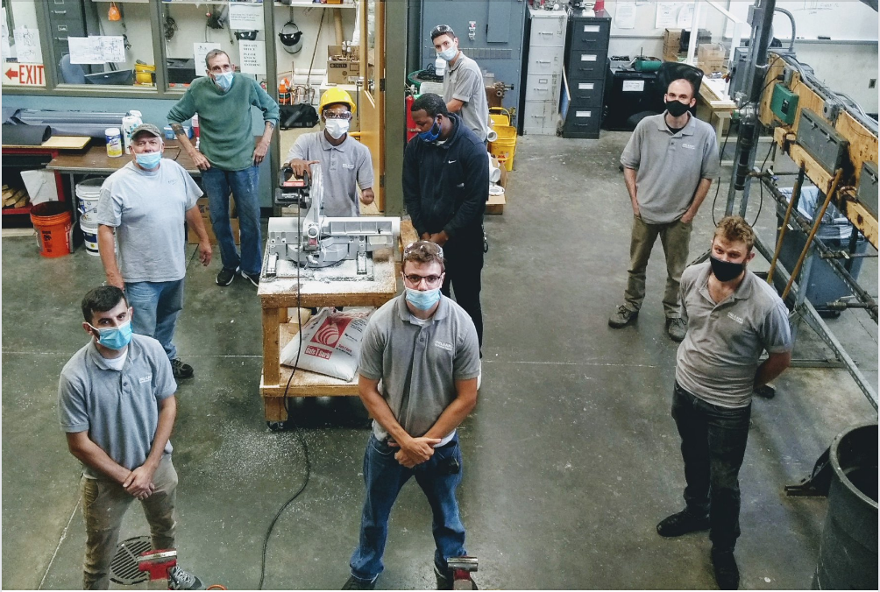A Plumbing and Heating class meets at Orleans Technical College, which has seen a surge in enrollment since the pandemic began. | Courtesy of Orleans Technical College
Stephanie Lees worked in the food and beverage industry selling wine and spirits before the coronavirus pandemic began.
The former manager at Butcher and Singer in Center City closed the restaurant the night before the onset of citywide shutdowns in March. She came back a few days later to lock dozens of bottles of expensive alcohol in the underground vault in case there was a break-in.
When it became clear the restaurant would not be opening again soon, she started looking for another job and studying for an advanced wine certification, but she couldn’t focus.
“It just seemed kind of stupid, with everything going on,” she said. “It was the first time in the last eight years that I wasn’t, like, eating it up and super excited about it.”
Stephanie Lees | Photo by Steven Auerbach. She lived alone in Old City, and the days of isolation blurred together. She started practicing Judaism with more intention, keeping kosher and thinking about finding a career that would make a difference in people’s lives. Her grandmother, who founded the Juvenile Diabetes Foundation (now JDRF), had always been an inspiration to her. She applied and was accepted to master’s programs in counseling at Rosemont College and La Salle University.
Lees is one of thousands of professionals who have made job switches or career changes during the economic upheaval of the past eight months. Whether due to layoffs, furloughs or a change in perspective brought about by a national crisis, Jewish professionals and organizations are pivoting to adapt to a new job market.
Jewish religious centers, nonprofits and cultural organizations have not been immune from rounds of pandemic-induced layoffs and furloughs. Ilana Aisen, CEO of JPRO Network, said organizations that relied on earned revenue have been the hardest hit.
“JCCs were under extraordinary stress almost immediately. So were synagogues, which rely on membership dues around High Holiday times,” she explained.
To help those coping with job loss, the Jewish Federations of North America partnered with JPRO Network to create Rise, a career services program for professionals in the American and Canadian Jewish world.
“We just felt it critical, given our mission and our mandate, to support people who go through the process of losing a job, which is often practically and emotionally shattering, and to make sure that our colleagues would land on their feet,” Aisen said.
Rise connects furloughed and out-of-work professionals with career coaches, financial information and mental health resources to build resilience.
“For people who work in the Jewish community, they’re here because they’re passionate about the mission, they love the work,” she said. “For many of us, it’s so deeply personal, and people go through all the stages of grieving because this is a major loss.”
While the goal is to keep as many professionals working in the Jewish world as possible, Rise also helps them find placements in other areas with the hope of keeping them in contact with other Jewish professionals until the economy improves.
JEVS Human Services has partnered with Rise to offer career counseling to clients who worked in the Jewish world. They have also been working with clients from various backgrounds and industries who need to make a job or career change during the pandemic.
Peggy Truitt, director of career strategies, noted that people with higher education who have been able to work from home have been less drastically impacted by job loss than those in the hospitality, retail and restaurant industries. Many of those job losses are becoming permanent as businesses are forced to close, and there is no way to know if they will ever come back.
“We know that so many restaurants have closed that there will be a lot less opportunity for those positions,” Truitt said.
Women across the economic spectrum are also more vulnerable to job loss due to the lack of available child care from schools and day care centers.
“Taking on the whole home front has been really impactful to their careers,” she said.
Truitt said JEVS career counselors work to help people identify whether they need a job change or want to change careers entirely. If the latter is necessary, they identify transferable skills, study the competition in other fields and assist with networking and rebranding.
People who worked in restaurants, for example, typically have excellent customer service skills and sales skills. Truitt said JEVS has helped these clients transfer to e-commerce, an industry that has boomed during the pandemic.
JEVS client Kathy Blum worked as a restaurant manager in the Scranton area for over 30 years before she moved to Northeast Philadelphia to be closer to family. At 62, she struggled to find another job due to her age, and she had no idea how to approach her job search when the pandemic hit.
“I was really drowning,” she said.
With the help of JEVS career counselor Jackie Savoy, she found a job working remotely as a contact tracer for Insight Global, which contracts with Pennsylvania’s state government. She plans to work there until the pandemic ends and then pivot into another customer service role.
Interest in trades like carpentry and plumbing is also booming among those looking to pivot into pandemic-proof fields. Orleans Technical College, the trade school run by JEVS, has seen a spike in enrollment and wait lists.
“We all live in houses that need repair and work in buildings that need maintenance,” said Debbie Bello, director of admissions.
Class size has decreased to accommodate social distancing guidelines, but students are still able to learn how to build an entire two-story house on the premises.
After dining restrictions were lifted, Lees got another job working at White Dog Cafe in University City, but helping people find escapism in dining out during a national crisis no longer felt meaningful.
“It showed me that I was very much wanting to change careers, because I could have stayed and could have grown with the company and continued in that path, but given a whole handful of things made the decision to leave,” she said. She quit her job during Sukkot and is now a full time graduate student at Rosemont College.
Lees estimates her master’s in counseling will take two years to complete. She hopes to work with people who have experienced domestic violence and family trauma once she is qualified.
spanzer@jewishexponent.com; 215-832-0729

